Build a SOHO Network:
Tasks :
1.
Draw a network diagram for a small office/home office (SOHO) setup that includes: one broadband internet connection, one Wi-Fi router, two laptops, one smart TV, and one printer. Clearly label each device and connection type (wired or wireless).
ANS :
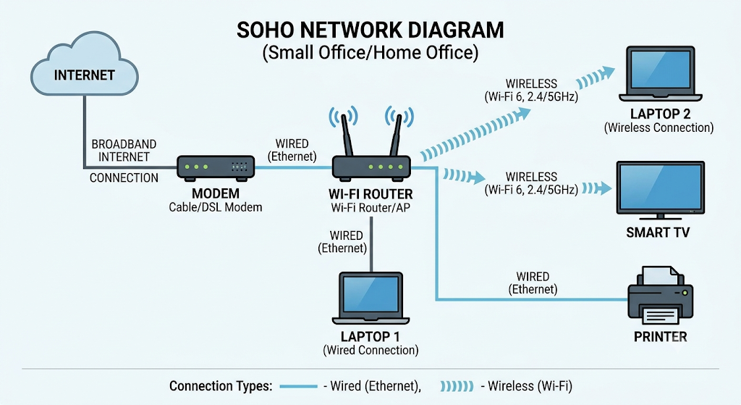

2.
List all the hardware components (with brand/model suggestions) you would need to physically build the SOHO network diagrammed above, including cables and any switches or extenders if needed.<br><br><em><strong>Hint:</strong> Check current listings on Flipkart or Amazon for typical device models used in Indian homes/offices.</em>
ANS :
Component | Quantity | Suggested Brand/Model | Purpose
Broadband Internet Connection | 1 | Airtel Xstream Fiber / JioFiber | Internet access
Modem/ONT | 1 | ISP Provided ONT/Modem | Connects to ISP
Wi-Fi Router | 1 | TP-Link Archer C6 AC1200 | Provides wired and wireless networking
Wi-Fi Router | 1 | TP-Link Archer C6 AC1200 | Provides wired and wireless networking
Laptop 1 | 1 | HP 15s / Dell Inspiron 15 | Wired workstation
Laptop 2 | 1 | HP 15s / Lenovo IdeaPad Slim 3 | HP 15s / Lenovo IdeaPad Slim 3
Smart TV | 1 | Samsung 43" Smart TV | Wireless entertainment device
Printer | 1 | HP LaserJet MFP 136w | Network printer
Cat6 Ethernet Cable (Modem → Router) | 1 | D-Link Cat6 | Wired connection
Cat6 Ethernet Cable (Modem → Laptop 1) | 1 | D-Link Cat6 | Wired connection
Cat6 Ethernet Cable (Modem →Printer) | 1 | D-Link Cat6 | Wired connection
Power Adapter (Router) | 1 | Included with Router | Power supply
Power Strip Extension Board | 1 | Anchor by Panasonic | Power distribution

3.
Write step-by-step instructions to configure the Wi-Fi router for your SOHO network, including setting up a unique SSID, enabling WPA2 security, and changing the default admin password.
ANS :

Step 1: Physical Connections
- Connect the modem to the router's WAN port using an Ethernet cable.
- Connect Laptop 1 to a LAN port on the router.
- Connect Printer to another LAN port on the router.
- Power on modem and router.

Step 2: Login to Router
- Open a browser on Laptop 1.
- Enter:
192.168.1.1
- Login using default credentials.
Example:
Username: admin
Password: admin

Step 3: Change Default Admin Password
Navigate to:
Administration → System Settings
Change:
Old Password: admin
New Password: SOHO_Admin@2026
Save settings.

Step 4: Configure Unique SSID
Navigate to:
Wireless Settings
Set:
SSID: SOHO_Office_Network
Save.

Step 5: Enable WPA2 Security
Navigate to:
Wireless Security
Configure:
Security Mode: WPA2-Personal
Encryption: AES
Password: SOHO@2026Secure
Save.

Step 6: Configure DHCP
Navigate to:
LAN Settings → DHCP
Enable:
DHCP Server: Enabled
Start IP: 192.168.1.100
End IP: 192.168.1.200
Save.
Step 7: Connect Devices
Wireless Devices
- Laptop 2
- Smart TV
Connect to:
SSID: SOHO_Office_Network
Password: SOHO@2026Secure
Wired Devices
- Laptop 1
- Printer
Already connected through Ethernet.
4.
Configure IP addresses for all devices in your SOHO network: assign static IPs to the printer and smart TV, and use DHCP for the laptops. Show a table listing each device, its MAC address (make one up), and the assigned IP address.
ANS :

Network Information :
Parameter | Value
Network Address | 192.168.1.0/24
Subnet Mask | 255.255.255.0
Default Gateway | 192.168.1.1
DNS Server | 8.8.8.8

Device IP Address Table :
Device | Connection Type | MAC Address (Example) | IP Addres | Assignment
Wi-Fi Router | Wired/Wireless | 00:AA:11:BB:22:01 | 192.168.1.1 | Static
Laptop 1 | Wired | 00:AA:11:BB:22:10 | 192.168.1.100 | DHCP
Laptop 2 | Wireless | 00:AA:11:BB:22:20 | 192.168.1.101 | DHCP
Smart TV | Wireless | 00:AA:11:BB:22:30 | 192.168.1.20 | Static
Printer | Wired | 00:AA:11:BB:22:40 | 192.168.1.10 | Static

Static IP Configuration
Printer
IP Address: 192.168.1.10
Subnet Mask: 255.255.255.0
Gateway: 192.168.1.1
DNS: 8.8.8.8

Smart TV
IP Address: 192.168.1.20
Subnet Mask: 255.255.255.0
Gateway: 192.168.1.1
DNS: 8.8.8.8
5.
Explain how you would troubleshoot if one of the laptops cannot connect to the internet in your SOHO network. List at least 3 possible causes and what steps you would take to diagnose and fix each issue.
ANS :
Cause 1: Wrong Wi-Fi Password
Symptoms
- Laptop sees Wi-Fi network.
- Connection fails.
Diagnosis
- Verify SSID:
SOHO_Office_Network
- Check entered password.
Fix
- Forget Wi-Fi network.
- Reconnect.
- Enter:
SOHO@2026Secure

Cause 2: DHCP Not Assigning IP Address
Symptoms
- Connected to Wi-Fi.
- No Internet access.
Diagnosis
Open Command Prompt:
ipconfig
Check IP address.
If:
169.254.x.x
DHCP failed.
Fix
Run:
ipconfig /release
ipconfig /renew
If still unsuccessful:
- Restart router.
- Verify DHCP server is enabled.

Cause 3: Router Not Connected to Internet
Symptoms
- Laptop connected to Wi-Fi.
- Websites do not open.
Diagnosis
Check:
- Internet LED on modem.
- Internet LED on router.
Try internet on Smart TV.
Fix
- Restart modem.
- Restart router.
- Check Ethernet cable between modem and router.
- Contact ISP if outage continues.

Cause 4: Wireless Adapter Disabled
Symptoms
- No Wi-Fi networks visible.
Diagnosis
Open:
Control Panel → Network Connections
Check Wi-Fi adapter status.
Fix
- Enable Wi-Fi adapter.
- Update wireless drivers.
- Restart laptop.

Cause 5: DNS Server Problem
Symptoms
- Google does not open.
- Wi-Fi connected.
Diagnosis
Run:
ping 8.8.8.8
If ping works but websites don't load, DNS is the issue.
Fix
Configure:
Preferred DNS: 8.8.8.8
Alternate DNS: 8.8.4.4

